

|  |  |  |  |  |  |  |  |  |
| --- | --- | --- | --- | --- | --- | --- | --- | --- |
|  | | | | | | | | |
|  | | Term Project Report | | | | |  | |
|  |  | | | | | | |  |
|  | | | |  |  | | | |
|  | | | | Zeynep Yıldız 29325 |  | | | |
|  | | | | 21.01.2023—CS 303— |  | | | |
|  | | |  | | |  | | |

**Code Structure:**

I parted what I have to do so it will be easier to manage.

I have a couple always blocks.

1: it checks the requests from all floors and inside the elevator, and determines the direction of the request. (floor_0_d, floor_1_d, ….and floor_0_p, floor_1_p,…) and approves the requests if they are okay to get. It will determine the destination floor too. I am gathering the requests in an array of floors. If it has to stop at a floor then it will make the corresponding index’s value 1. And depending on where it gets the requests it will light up the appropriate lights too. This is the first always @ block in my code.

Also depending on the current_floor it will close the lights and change the array.

2: This is responsible for the movement of the elevator. It will get the request list and the destination and change the state of the elevator and the current floor it is in. Also it will turn on and off the timer when it changes floors.

3-4: timer blocks. So that the elevator will wait 5 seconds before it changes the floors.

5: This gets the current floor and state of the elevator and changes SSD values to show the floor and the state the elevator is in.

All of them has reset scenario (?) that will reset every variable they are responsible for.

Scenario 1:

* Elevator is at floor 0.
* Elevator is made to go to floor 3 by pressing the button inside the elevator.
* While going there it is requested to stop from floors 1, 2 and 4 (1 and 2 requested go up).
* It takes the requests from 1 and 2 but not 4. (You can see this by looking at leds)

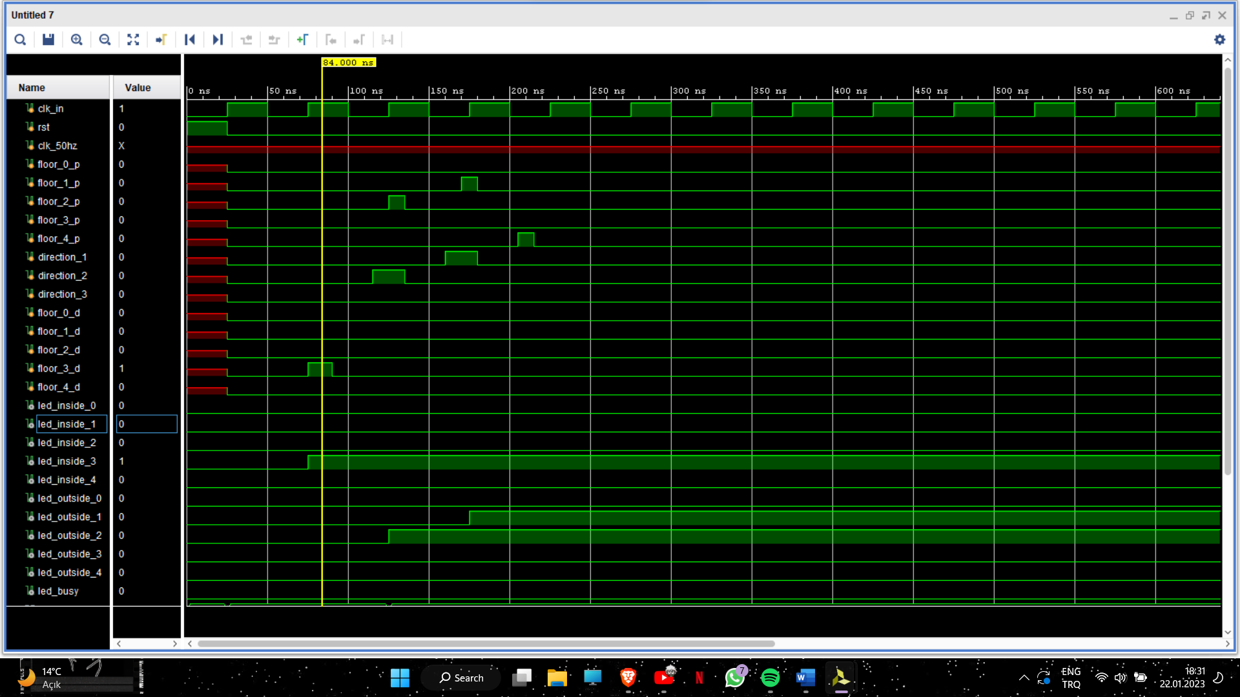

Scenario 2:

* Elevator is at floor 0.
* Elevator is made to go to floor 3 by pressing the button inside the elevator.
* While going there it is requested to stop from floors 1, 2 and 4 (floor 2 requested go up, floor 1 requested go down).
* It takes the requests from 2 but not 1 and 4. (You can see this by looking at leds)

Unfortunately I cannot show the changements in the SSD because it is set to change in every 5 seconds but the fast simulation only go to max of 1000 ns ion my computer for some reason. And also I can’t show more than 1 second of simulation since it takes unbelievably long time to simulate. Even though I could show 1 second, I have to simulate more than 5 to show the changes in SSD and that is not possible for me unfortunately. My CPU can’t take it. But I tested these in the FPGA over and over again. It indeed works. TA also checked.  
  
So I can’t show scenarios like “current floor is 3 and it is requested to go 1 and while going it is requested from floor 4 and/or while going it is requested to stop at floor 2”. But all scenarios like these that I could think of, I tried them while I was at the lab at Saturday (21.01.2023) and the TA also saw these.

Thank you for your time.